Chapter 9, Solution 34.

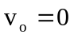when jX_{L}–jX_{C} = 0 so X_{L} = X_{C} or 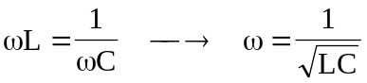.

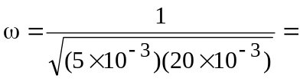 100 rad/s

